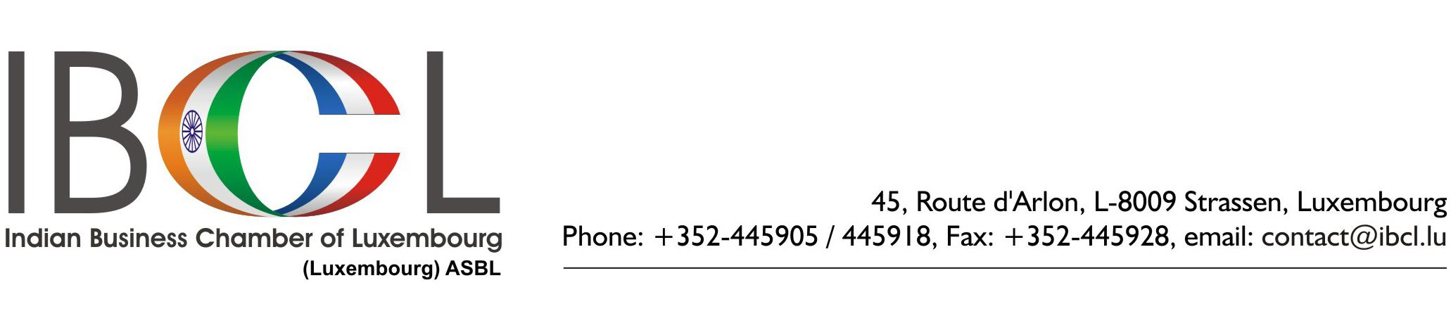
January 30th, 2012
INVITATION

The Indian Business Chamber of Luxembourg invites you to the Seminar on:

“IP for Enterprise Competitiveness”

Thursday, March 1st, 2012 - 18.00 hours

Venue: BGL BNP Paribas, Avenue Monterey, (entrance: Rue Notre-Dame / Boulevard Royal corner) Luxembourg

Context:

IP is one of your most valuable business assets. It can increase competitiveness and contribute to the success of a business. It may be protected by patents, trade marks, copyright and registered designs.

Speakers:

Mr. Narendra Sabharwal, former Deputy Director General, World Intellectual Property Organisation, Geneva: He managed and supervised the development of cooperation, technical assistance and capacity building;

program of WIPO in intellectual property in least developed, developing countries and countries in transition.
Mr. Lex Kaufhold, Director, IP Office, Ministry of Economy and Foreign Trade, Luxembourg: He is in charge of all matters concerning patents, trademarks, design and authors' rights in Luxembourg, and represents the Luxembourgish government in international IP organizations such as the OAMI, the EPO, the WIPO, etc.
Mr. Frank Muntendam, Partner and Head of International Tax Services, Ernst & Young, Luxembourg: He is a member of the International Fiscal Association of Luxembourg and of the Dutch Bar of Tax Advisors. He has published several articles in leading magazines on international taxation.
Mrs. Karin Schintgen, Director, BGL BNP Paribas, Luxembourg: She is in charge of Intellectual Property developments, Corporate Social Responsibility and External Relations at BGL BNP Paribas.
Registration starts at 18h00. Presentations are from 18h30 to 20h00, followed by a networking cocktail

Participation: Members: Free / Non-members: Euro.20 - payable in cash at the entrance

Registration: On-line: http://www.ibcl.lu/events.php Email: register@ibcl.lu

This Event is sponsored by:

